Lab practical 11
COA
1(a) Write a program in assembly language to find L.C.M of two single-digit numbers.
Code:
.model small
.stack 100h
.data
num1 db 8 ; First number (single byte)
num2 db 4 ; Second number (single byte)
gcd_res db 0 ; To store GCD result (single byte)
lcm_res dw 0 ; To store LCM result (two bytes for larger result)
msg db 'LCM is: $' ; Message to display before the result
.code
main:
mov ax, @data
mov ds, ax ; Initialize data segment
; Load num1 and num2 into AL and BL for GCD calculation
mov al, num1
mov bl, num2
call gcd ; Calculate GCD of num1 and num2
mov gcd_res, al ; Store GCD in gcd_res
; Calculate LCM using (num1 * num2) / GCD
mov al, num1 ; Load num1 into AL
mov ah, 0 ; Clear AH for 16-bit multiplication
mov dl, num2 ; Load num2 into DL
mul dl ; AX = num1 * num2 (result in AX)
; Divide AX by the GCD (stored in gcd_res)
mov cl, gcd_res ; Load GCD into CL
div cl ; AX = (num1 * num2) / GCD
; Store the result in lcm_res
mov lcm_res, ax
; Display "LCM is: "
mov ah, 09h ; DOS interrupt to display string
lea dx, msg ; Load the address of the message into DX
int 21h
; Display the LCM result (convert to ASCII and print)
mov ax, lcm_res ; Load LCM result into AX
call print_num ; Call function to print number
; End the program
mov ah, 4Ch
int 21h
; Function to calculate GCD using the Euclidean algorithm
gcd proc
cmp bl, 0
je end_gcd ; If BL = 0, GCD is in AL
gcd_loop:
mov ah, 0
div bl ; Divide AL by BL, remainder in AH
mov al, bl ; Move BL to AL (new A)
mov bl, ah ; Move remainder to BL (new B)
cmp bl, 0
jne gcd_loop ; Repeat until remainder (B) = 0
end_gcd:
ret ; Final GCD is in AL
gcd endp
; Function to print a number in AX
print_num proc
; Divide the number by 10 and print each digit
mov cx, 0 ; Clear CX (will store digits)
mov bx, 10 ; Divisor for base-10
convert_loop:
xor dx, dx ; Clear DX before division
div bx ; AX / 10, quotient in AX, remainder in DX
push dx ; Save remainder (digit) on the stack
inc cx ; Increment digit count
cmp ax, 0
jne convert_loop ; Repeat until the quotient is 0
print_digits:
pop dx ; Get digit from stack
add dl, '0' ; Convert digit to ASCII
mov ah, 02h ; DOS interrupt to print character
int 21h
loop print_digits ; Repeat for all digits
ret
print_num endp
end main
OUTPUT:
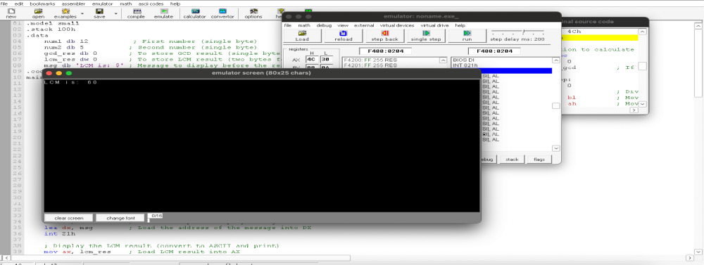
1. (b) Write an assembly language program to display the nth term of a fibonacci series. “n”
must be a single digit number which may be taken from the user.
CODE:
.model small
.stack 100h
.data
prompt db 'Enter a single digit number (0-9) for n: $'
result_msg db 0Dh,0Ah,'The nth Fibonacci number is: $'
fib dw 0 ; Store the nth Fibonacci number in a word (16 bits)
.code
main proc
; Initialize data segment
mov ax, @data
mov ds, ax
; Prompt the user for input
mov ah, 09h
lea dx, prompt
int 21h
; Read a single character input
mov ah, 01h
int 21h
sub al, '0' ; Convert ASCII to integer (0-9)
mov cl, al ; Store n in cl
; Check for n = 0 or n = 1 directly
cmp cl, 1
jbe single_digit_fib
; For n > 1, calculate Fibonacci using loop
; Initialize Fibonacci values
mov ax, 0 ; First Fibonacci number (16-bit for larger values)
mov bx, 1 ; Second Fibonacci number (16-bit)
fib_loop:
dec cl ; Decrease count
jz store_result ; If count reaches zero, store result
; Calculate next Fibonacci number
add ax, bx ; F_n = F_(n-1) + F_(n-2)
xchg ax, bx ; Move F_(n-1) to F_(n-2) and update F_(n-1)
jmp fib_loop ; Repeat loop until cl = 0
store_result:
mov fib, ax ; Store the result in fib
single_digit_fib:
; For n = 0 or 1, bx already contains the correct Fibonacci number
cmp cl, 0
je show_fib0
mov fib, bx ; For n=1, F_1 is 1
jmp display_result
show_fib0:
mov fib, ax ; For n=0, F_0 is 0
display_result:
; Display result message
mov ah, 09h
lea dx, result_msg
int 21h
; Convert the result in `fib` to ASCII and display
mov ax, fib ; Load result into ax
call print_number ; Call subroutine to print the number
; Exit program
mov ah, 4Ch
int 21h
main endp
; Subroutine to print a number in AX as ASCII
print_number proc
; Divide ax by 10 repeatedly to extract each digit in reverse
mov cx, 10 ; Set base to 10
mov bx, 0 ; Initialize bx as digit storage
reverse_digits:
xor dx, dx ; Clear dx for division
div cx ; AX / 10, quotient in AX, remainder in DX
push dx ; Push remainder onto stack (digit)
inc bx ; Count digits
test ax, ax ; Check if quotient is 0
jnz reverse_digits
display_digits:
pop dx ; Get last pushed digit
add dl, '0' ; Convert to ASCII
mov ah, 02h ; DOS print character function
int 21h ; Display character
dec bx ; Decrement digit count
jnz display_digits
ret
print_number endp
end main

OUTPUT:
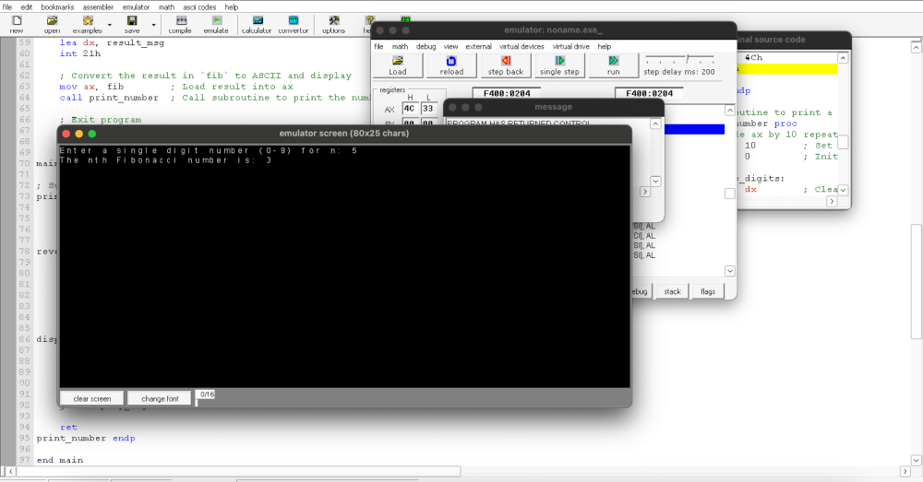

2. Write an assembly language program to find the factorial of a given single-digit number.
CODE:
.model small
.stack 100h
.data
prompt db 'Enter a single digit number (0-9): $'
result_msg db 0Dh,0Ah,'The factorial is: $'
factorial dw 1 ; 16-bit variable to store factorial result
.code
main proc
; Initialize data segment
mov ax, @data
mov ds, ax
; Display prompt to enter a number
mov ah, 09h
lea dx, prompt
int 21h
; Read a single character input
mov ah, 01h
int 21h
sub al, '0' ; Convert ASCII to integer
mov bl, al ; Store the number in BL for calculation
; Special case for 0! which is 1
cmp bl, 0
jne calculate_factorial
mov factorial, 1
jmp display_result
calculate_factorial:
mov cx, bx ; Set loop counter to the number entered (n)
mov ax, 1 ; AX will store the ongoing factorial result
factorial_loop:
mul cx ; AX = AX * CX (calculate factorial)
loop factorial_loop ; Decrement CX and repeat until CX = 0
mov factorial, ax ; Store final factorial result in 'factorial'
display_result:
; Display result message
mov ah, 09h
lea dx, result_msg
int 21h
; Convert the result in `factorial` to ASCII and display
mov ax, factorial ; Load factorial result into AX
call print_number ; Call subroutine to print the number
; Exit program
mov ah, 4Ch
int 21h
main endp
; Subroutine to print a number in AX as ASCII
print_number proc
; Divide ax by 10 repeatedly to extract each digit in reverse
mov cx, 10 ; Set base to 10
mov bx, 0 ; Initialize bx as digit storage
reverse_digits:
xor dx, dx ; Clear dx for division
div cx ; AX / 10, quotient in AX, remainder in DX
push dx ; Push remainder onto stack (digit)
inc bx ; Count digits
test ax, ax ; Check if quotient is 0
jnz reverse_digits
display_digits:
pop dx ; Get last pushed digit
add dl, '0' ; Convert to ASCII
mov ah, 02h ; DOS print character function
int 21h ; Display character
dec bx ; Decrement digit count
jnz display_digits
ret
print_number endp
end main

OUTPUT:
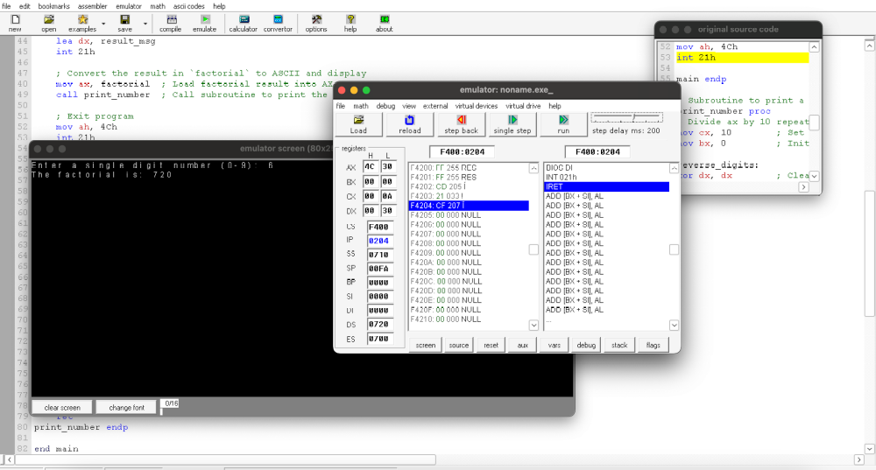

GITHUB:
https://github.com/srijachakilam15/COA/blob/main/lab%20practical%2003.docx

